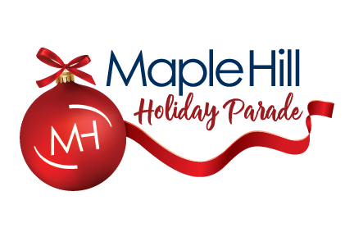
2022 Sponsorship Package Pricing

Maple Hill Auto Group is honored to be the presenter of the Maple Hill Holiday Parade Kalamazoo. The 59th annual parade is a long-standing tradition and has been part of the fabric of the community since Gilmore Department store started it in 1962. Featuring high school marching bands, giant balloons, floats, and businesses and organizations, this is one event that truly defines community. The Kalamazoo Holiday Parade attracts nearly 30,000 spectators, and over 3,000 people who create the line-up (entertainment).

Helium $4,000
- Presenting Sponsor Status​​
- Listed as presenting sponsor of the balloon, denoted with a banner/sign in the parade
- Featured in TV3 ads with LARGE logo throughout all commercials
- Facebook posts
  - exclusive recognition and top logo placement​
  - Facebook cover picture
  - Included in Facebook Ads
  - Testimonial rich info post 2x
- Website Logo Placement LARGE with link
- Event Day Exposure
  - Sponsor Banner​
  - Parade Day Activity Booth
  - ​Product Placement Opportunities​
- Content Kit

Cold Air $3,000
- Presenting Sponsor Status
- Listed as presenting sponsor of your balloon with banner/sign in the parade
- Featured TV3 ads with MEDIUM logo throughout all commercials
- Facebook posts
  - Exclusive recognition​
  - Cover image
  - Included in Facebook ads
  - Information-rich testimonial post
- Website logo placement MEDIUM with link
- Event Day Exposure
  - Sponsor banner​
  - Parade Day activity Booth
  - Product Placement Opportunities
- Content Kit

Event Day/WMU Band $3,000
(Sponsors from last year have first right of refusal before May 31st)
- Presenting Sponsor Status​​
- Listed as presenting sponsor, denoted with a banner/sign in the parade
- Featured in TV3 ads with MEDIUM logo throughout all commercials
- Facebook posts
  - exclusive recognition and top logo placement​
  - Facebook cover picture
  - Included in Facebook Ads
  - Testimonial rich info post
- Website Logo Placement MEDIUM with link
- Event Day Exposure
  - Sponsor Banner​
  - Parade Day Activity Booth
  - ​Product Placement Opportunities​
- Content Kit

Gold Sponsor $2,000
- Gold status
  - large logo where applicable ​
- Logo in final “Thank you” commercial
- Facebook posts
  - Gold sponsor group post​
  - testimonial post
- Event Day exposure
  - Parade day booth​
  - product placement
- Content kit

Silver Sponsor $1,500
- Silver status
  - medium logo where applicable ​
- Facebook
  - Silver sponsor group post​
  - testimonial post
- Event day exposure
  - booth​
  - product placement
- Content kit

Bronze Sponsor $1,000
- Bronze Sponsor Status
  - small logo where applicable​
- Facebook
  - Bronze sponsor group post​
  - testimonial post​​
- Event day exposure
  - booth​
  - product placement
- Content kit

Contact: Abby VandenBerg (avandenberg@maplehillauto.com) or Deb Droppers (deb@eventkalamazoo.com)
KELC Events – event team – 269-388-2830
1417 S. Burdick Street, Kalamazoo, MI 49001 - www.kalamazooholidayparade.org

